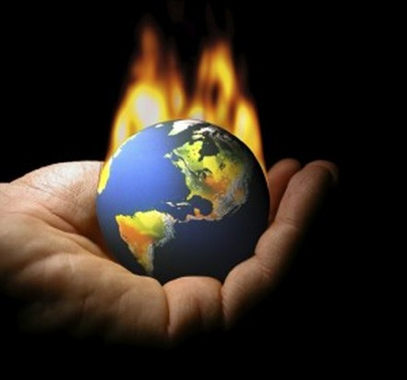

**There is so much going on in our world.**

**CONFLICT**

**There is so much going on in our world.**

**CONFLICT**

**UNDERSTANDING**

Check out GoWYLD.net for databases that will provide information for a better understanding on the what, why and where.

**Global Issues In Context CultureGrams**

**GoWYLD.net**

**UNDERSTANDING**

Check out GoWYLD.net for databases that will provide information for a better understanding on the what, why and where.

**Global Issues In Context CultureGrams**

**GoWYLD.net**