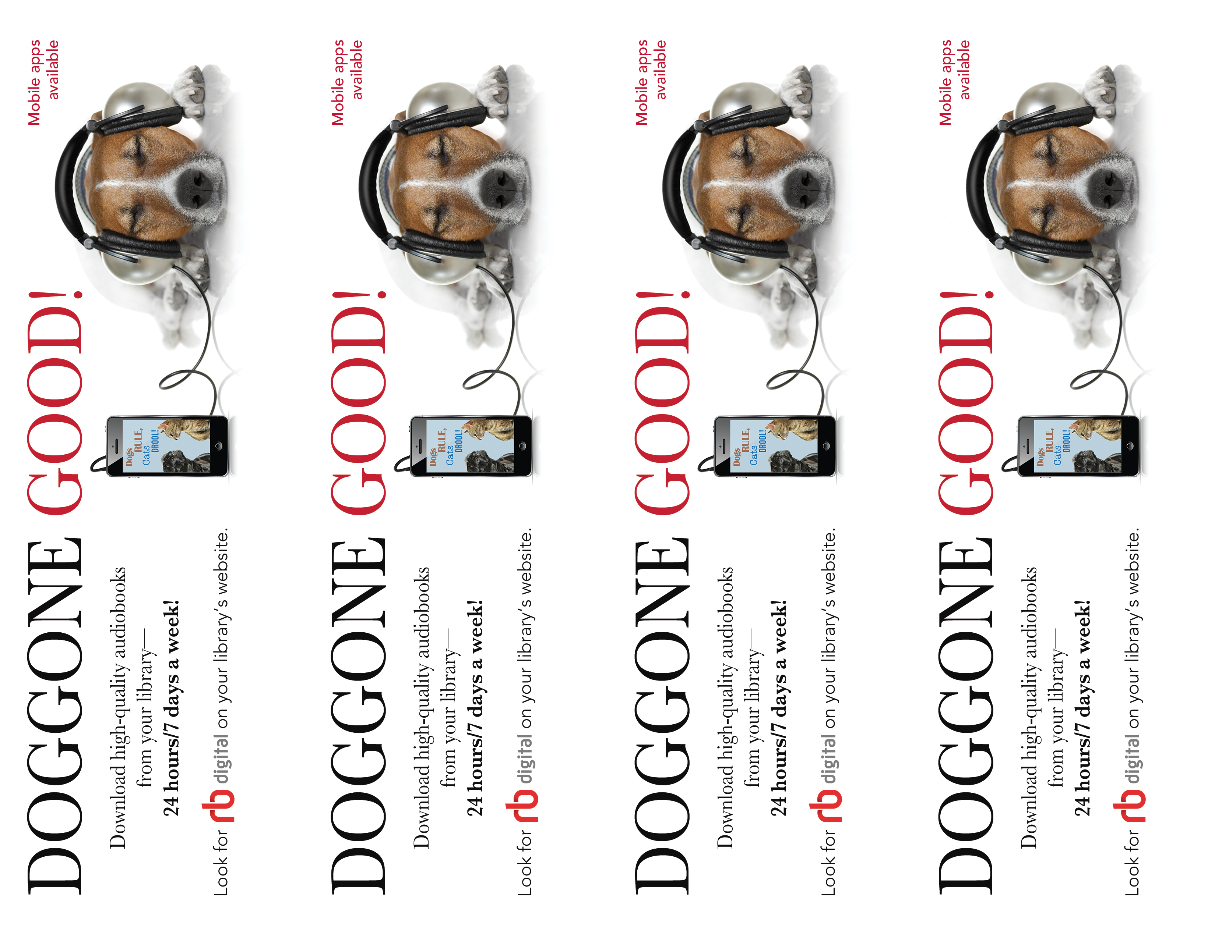

[insert library URL] [insert library logo]

[insert library URL] [insert library logo]

[insert library URL] [insert library logo]

[insert library URL] [insert library logo]