Social Media Posts
Always include your library’s web page with information on how to access ChiltonLibray or the ChiltonLibray access page itself. Shorten links with bit.ly, if needed.
1 | Post text | Link | Picture | FB | Twitter
2 | On the eve of National Car Care month, it’s worth noting Chilton, the most trusted name in auto repair was incorporated March 31, 1904 as Chilton Company of Pennsylvania. Our patrons can access the most updated source in car care, ChiltonLibrary on our website. | <link to access> | No | Yes | No
3 | April is National Car Care Month, what are you doing to show your vehicle some love? Look to ChiltonLibrary found on our website for your car’s maintenance intervals and service bulletins. | <link to access> | No | Yes | No
4 | National Car Care Month Trivia: In what year did the steering wheel replace the steering tiller? ChiltonLibrary can provide you with more insight on your steering wheel today if you’re having problems.  Comment with answer: 1898 | <link to access> | Yes | Yes | No
5 | Turn to our ChiltonLibrary for the most reliable, up-to-date car repair guidance. Get the latest recall info too! | <link to access> | Yes | Yes | Yes
6 | Visit our ChiltonLibrary for your one-stop source for car repair info covering most makes, models and years. | <link to access> | Yes | Yes | Yes
7 | Add hair conditioner (with lanolin) to your soap and your car will shine and repel rain. April is National Car Care Month, visit ChiltonLibrary found on our website, the most trusted name in car repair. | <link to access> | Yes | Yes | No
8 | National Car Care Month Tip of the Day: Park your car facing east to defrost the windows in the morning. | <link to access> | Yes | No | Yes
9 | National Car Care Month Tip of the Day: A plunger will remove small dents. | <link to access> | Yes | Yes | Yes
10 | National Car Care Month Tip of the Day: Use wet newspaper to removes stubborn stickers on car windows | <link to access> | Yes | No | Yes
11 | National Car Care Month Tip of the Day: The more keys on your chain, the more quickly your ignition lock/switch will fail. | <link to access> | Yes | Yes | No
12 | National Car Care Month Tip of the Day: Place a dryer sheet in your cabin filter to freshen your circulating air. | <link to access> | Yes | No | Yes
13 | National Car Care Month Tip of the Day: Putting your key fob to your chin will increase its range. | <link to access> | Yes | No | Yes
14 | National Car Care Month Tip of the Day: Prevent someone from stealing your registration sticker by cross-cutting it with a razor blade. | <link to access> | Yes | No | No
15 | National Car Care Month Tip of the Day: Toothpaste will clean foggy headlights and paint scuffs. | <link to access> | Yes | Yes | Yes
16 | National Car Care Month Tip of the Day: Hanging a tennis ball from your garage ceiling can help prevent parking to close to the garage wall. | <link to access> | No | Yes | Yes
17 | National Car Care Month Tip of the Day: 10 seconds of idling wastes more fuel that restarting your engine. | <link to access> | Yes | Yes | Yes
18 | Did you know you can get comprehensive, dynamic online auto repair support available 24/7 at your library with Chilton?! | <link to access> | No | No | Yes
19 | Access to authoritative, money-saving auto repair guides here today! | <link to access> | Yes | No | Yes
20 | Did you know you can get 24/7 access to Chilton’s money saving online auto repair manuals from any computer, phone or tablet?! | <link to access> | No | No | Yes
21 | Did you know audio content from the Repair section in ChiltonLibrary can be downloaded in MP3 format to save and access offline? Check it out here: <link to access> | <link to access> | No | No | Yes
22 | ChiltonLibrary’s dynamic search engine helps users find specific procedures quickly and offers other benefits. | <link to access> | Yes | No | Yes
23 | We have domestic and import vehicle information through the current model year, updated continuously by Chilton. | <link to access> | Yes | No | Yes
24 | Is your car in need of auto repairs? Access step-by-step instructions and videos from Chilton. | <link to access> | No | No | Yes
25 | Auto repair, maintenance, labor estimating, and bulletin/recall information is available through Chilton. | <link to access> | Yes | No | Yes
26 | Be pothole prepared with suspension, steering, tires, wheels & alignment data from ChiltonLibrary! ‬‬ | <link to access> | No | No | Yes
27 | Need a little help fixing your car? Access step-by-step instructions and videos from Chilton. | <link to access> | Yes | No | Yes
28 | Does your car make a funny noise? Checking service and recall bulletins can save time, money and frustration. That’s where ChiltonLibrary can help! | <link to access> | No | Yes | Yes

Picture 4
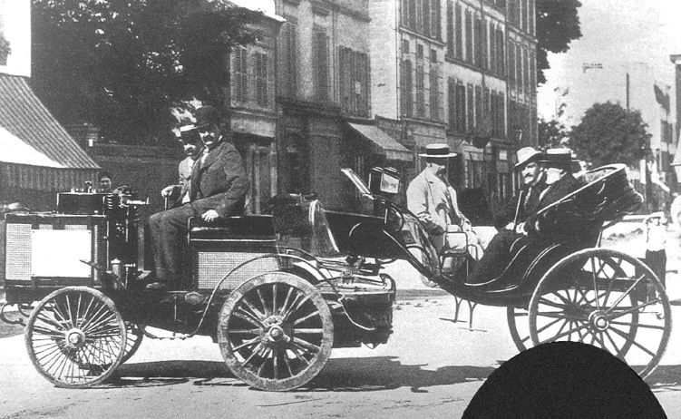

Picture 5
Picture 6
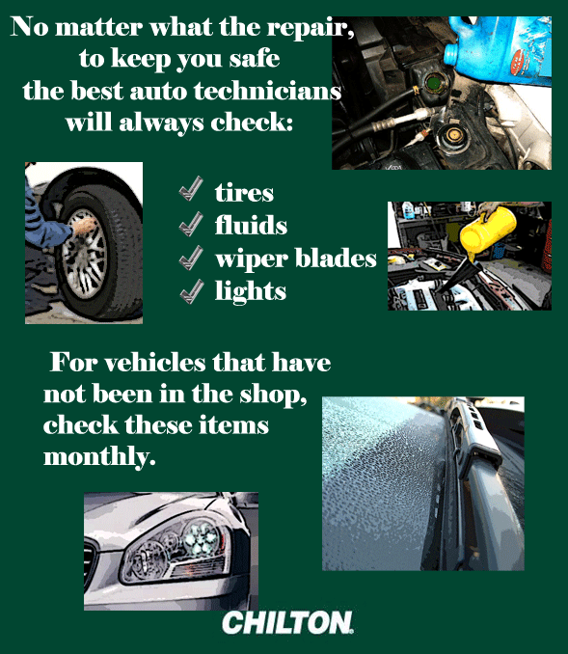

Picture 7
Picture 9
Picture 11
Picture 15
Picture 18:
