IMMEDIATE RELEASE – APRIL 29, 2021
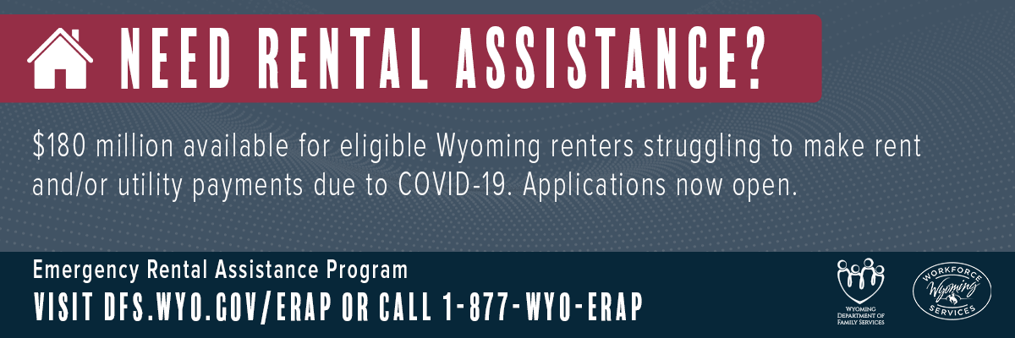

Emergency Rental Assistance Program is open for online applications

CHEYENNE, Wyo. - Do you rent your home in Wyoming and have been unable to make rent, internet and utility payments due to the COVID-19 pandemic? You may be eligible for the Emergency Rental Assistance Program (ERAP), which opened on April 29 for applications at DFS.WYO.GOV/ERAP.

Wyoming received $200 million in federal funding for the program, a U.S. Treasury initiative passed through the Consolidated Appropriations Act of 2021 and expanded by the American Rescue Plan Act of 2021. Under the new federal guidelines, $180 million is available for direct financial assistance for rent, utility, and internet payments and housing stability services, while $20 million is available for application assistance and administrative costs. The new guidelines have extended the program through December 31, 2021.

“The flexibility of the Emergency Rental Assistance Program gives us the opportunity to help more people keep a roof over their head and focus on getting back up on their feet,” Department of Family Services Director Korin Schmidt said. “The new program has been expanded to include the internet and utilities and pays current and future unpaid bills for eligible Wyoming renters.”

There are four criteria to be eligible for ERAP from the State of Wyoming:

- One or more individuals within the household is obligated to pay rent on a home in Wyoming or has unpaid rent on a previous residence that is located in Wyoming. If living on the Wind River Reservation, renters may be eligible for assistance through the Eastern Shoshone ERAP or Northern Arapaho ERAP.
- Total household income is equal to or less than eighty percent (80%) of the area median income.
- One or more individuals within the household has qualified for unemployment benefits or experienced financial loss due, directly or indirectly, to COVID-19.
- One or more individuals within the household can demonstrate a risk of experiencing homelessness or housing stability

Eligible households can obtain assistance for unpaid current and future rent, internet and utility payments. Eligible utility costs include electricity, energy costs (fuel, oil, propane), water and sewer, and internet service (up to $50 per month). Other eligible expenses, done on a case by case basis, may include reasonable relocation expenses, security deposits and reasonable late fees.

Unpaid bills must be for services on or after March 13, 2020 and can be on a former residence in Wyoming. There is no monetary limit, and eligible applications can receive assistance for up to 15 months.

Renters must submit the applications for assistance online at DFS.WYO.GOV/ERAP. Landlords can apply with the written permission of the renter. There is no copay or application fee.

ERAP directly pays landlords and utility companies for unpaid bills on behalf of eligible renters in Wyoming. The payments will be made by the State of Wyoming, so landlords must be an enrolled vendor with the Wyoming State Auditor’s Office at sao.wyo.gov/vendors. The fastest way to receive payment is through direct deposit.

If needing assistance with an application, there are community based organizations being set up in counties to provide help. (Click here for an updated list) For ERAP support, call center hours are 9 a.m. – 6 p.m. Monday through Friday. The toll-free phone number is 1-877-WYO-ERAP.

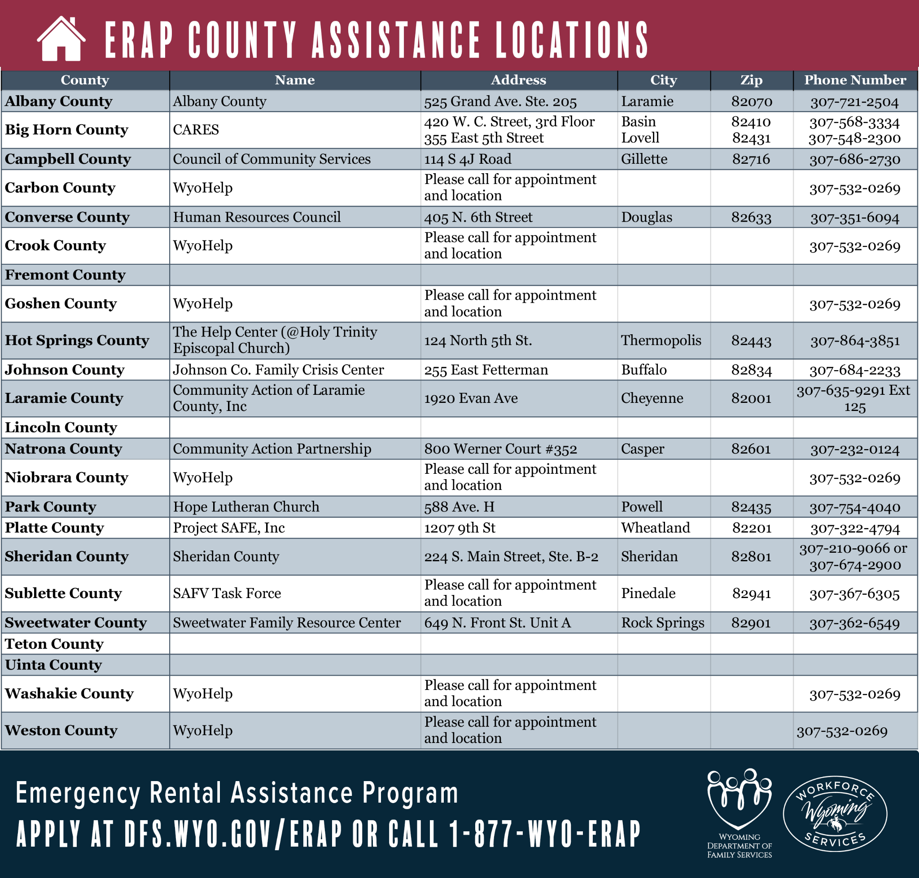

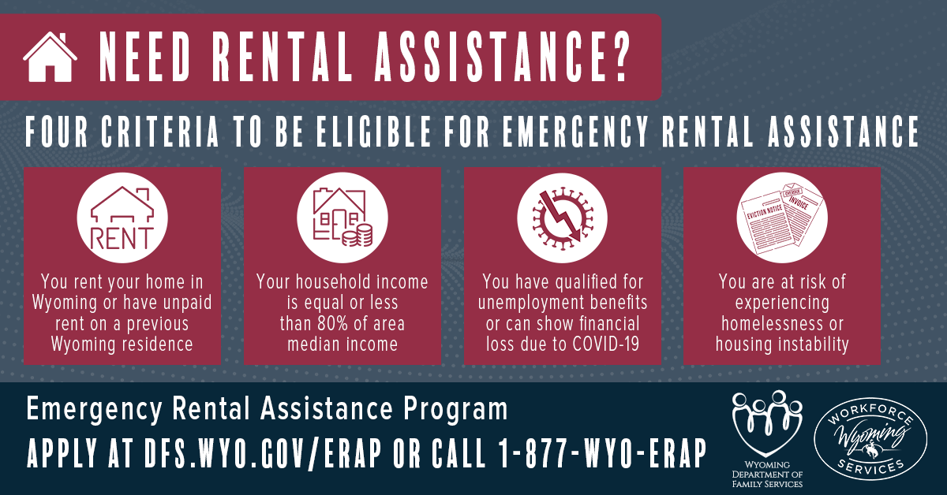

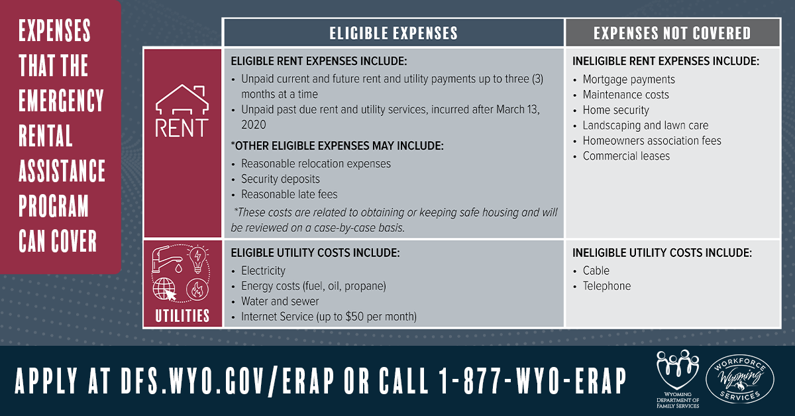

ABOUT ERAP
The Wyoming Department of Family Services, with assistance from the Department of Workforce Services, is administering the state’s Emergency Rental Assistance Program (ERAP), a U.S. Treasury initiative passed through the Consolidated Appropriations Act of 2021 and expanded by the American Rescue Plan Act of 2021. Wyoming received $200 million in federal funding to help eligible Wyoming renters struggling to make rent and/or utility payments due to the COVID-19 pandemic. Under the new federal guidelines, $180 million is available for direct financial assistance for rent, utility, and internet payments and housing stability services, while $20 million is available for application assistance and administrative costs.
Learn more at dfs.wyo.gov/erap.

PROGRAM QUESTIONS
If you have any questions, please email to RentalAssistance@wyo.gov.

MEDIA INQUIRIES ONLY CONTACT:
Rachel Girt, ERAP Communications Contractor
Rachel@girtcommunications.com | 307.286.1592

